

**Task 2: Preparing Urban Data Layers (Urban Data Input Tool)**

**Description**

This exercise offers the experience of a complete workflow of mapping **urban data (frontages, entrances and land uses)** using the **Space Syntax standards** for QGIS.

**Stage 1 – Frontages data input**

1. **Prepare the project**
   1. Open the **sample data project** (sample_data.qgs)
   2. Make sure the **‘Building’ layer is present** in the layers panel
   3. Start the **UrbanDataInput tool** from the Space Syntax Toolkit menu or toolbar
   4. Select the **‘Frontage’** tab

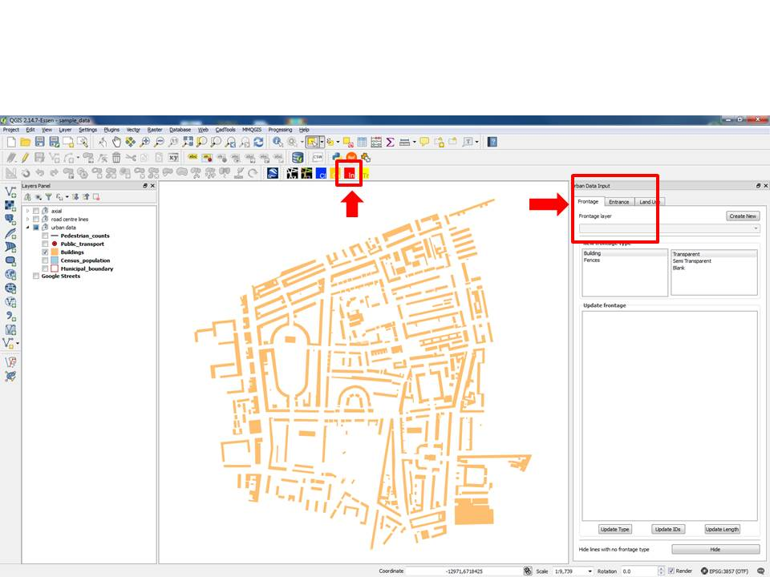

1. **Create frontage layer**
   1. Click the **‘Create New’** button
   2. There are several ways to get started with a new frontage layer, we try one
   3. Memory layer from existing building layer:
      1. **Don’t set** the save location
      2. Select the **‘Use building layer’** check box.
      3. Select the **‘buildings’ layers** from the drop-down menu.
      4. Click **OK**
   4. The memory layer is a **temporary layer** that **disappears** after closing QGIS. You need to **save it** **as a shape file** to keep the data.

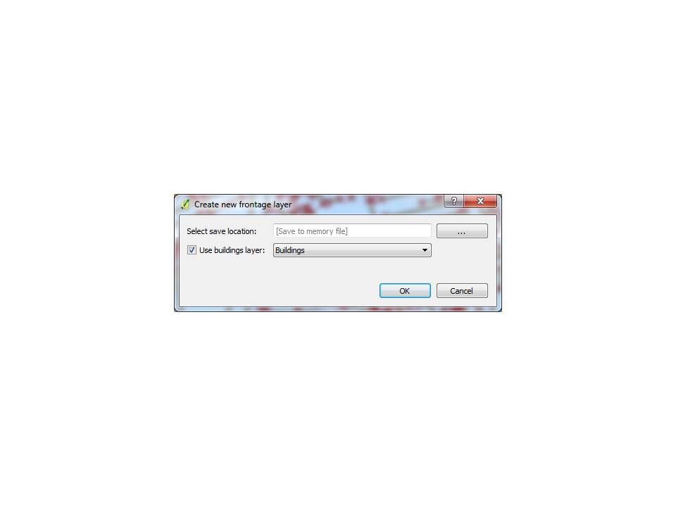

1. **Draw frontages**
   1. Choose one of the following options:
      1. Building
      2. Fences
   2. If you choose **‘Building’**, you can choose the following sub categories-
      1. Transparent (e.g. shop fronts with large windows)
      2. Semi-transparent (e.g. wall with some windows)
      3. Blank (e.g. blank wall with no windows)
   3. If you choose **‘Fences’**, you can further choose from the following sub categories -
      1. High Opaque Fence (or wall)
      2. High See Through Fence
      3. Low Fence (e.g. below waist level)
   4. Select the **‘Add Feature’** from the Digitizing QGIS toolbar.
   5. Draw lines along the respective building.

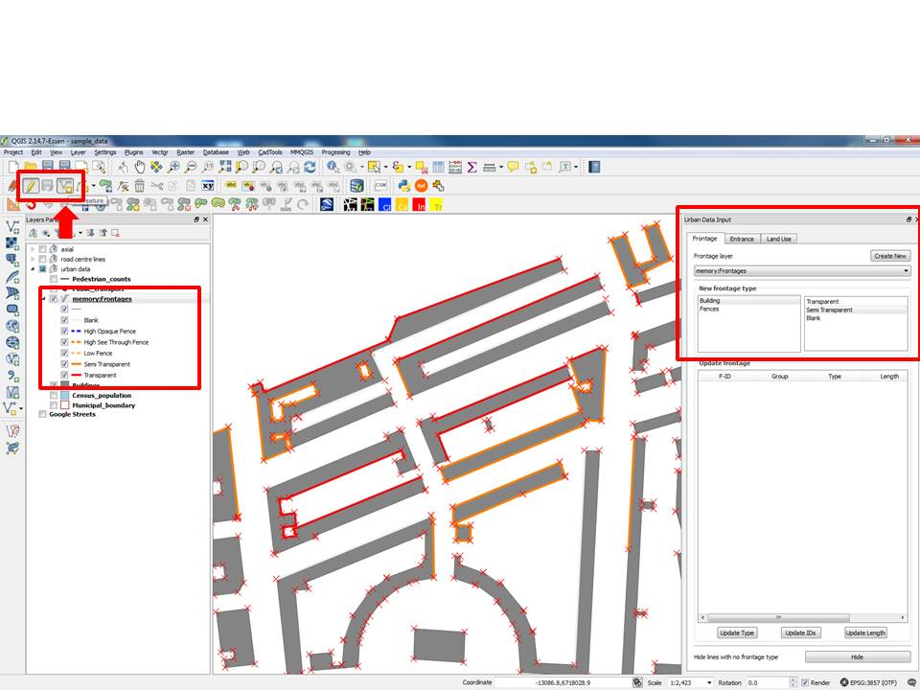

1. **Update frontages**
   1. Select the **Frontage (line)** to update
   2. Observe the attribute values in the data table
   3. Choose one of the following options:
      1. Building
      2. Fences
   4. If you choose ‘Building’, you can set one of the sub categories (see above)
   5. If you choose ‘Fences’, you can further set from the sub category (see above)
   6. Click **‘Update Type’** at the **bottom left** on the Urban Data Input tool panel

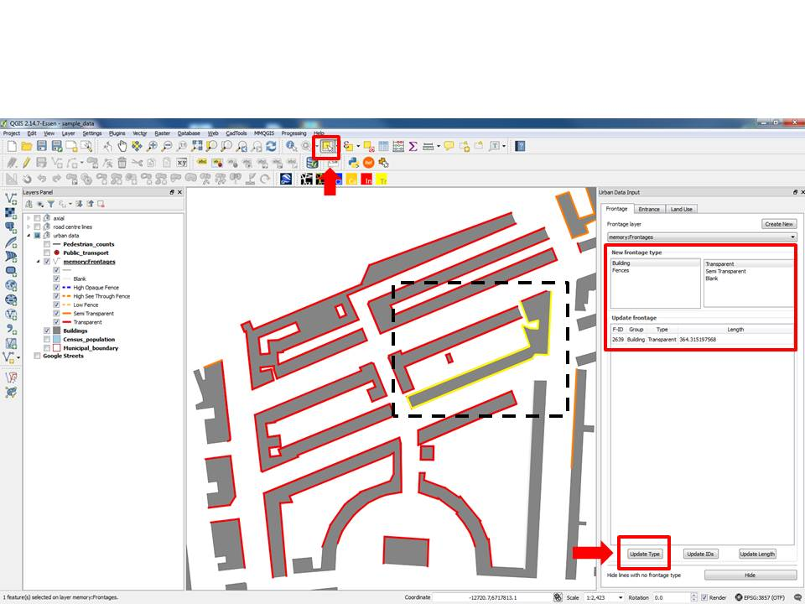

1. **View attributes of selected features of the frontage layer**
   1. Use the **‘Select features’** QGIS tool to select the required frontages.
   2. The attributes related to the selected frontages will now be displayed in the Urban Data Input

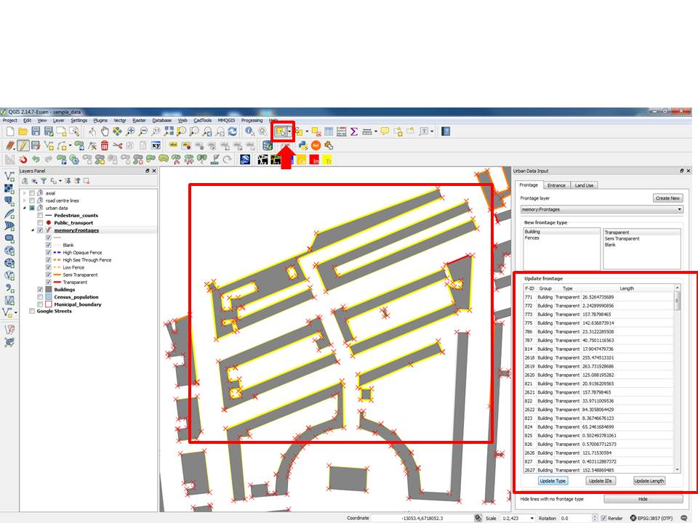

1. **Update Frontages ID**
   1. If you have a Frontage layer loaded on the map canvas press **‘Update IDs’** to update the **‘F-ID’** attribute of the Frontage layer
2. **Update Frontages Length**
   1. If you have a Frontage layer loaded on the map canvas press **‘Update Length’** to update the **‘Length’** attribute of the Frontage layer
3. **Hide frontages**
   1. To hide the lines with no value for Frontage type press the **‘Hide’** button at the bottom right of the tool.
   2. To make the lines with no value for Frontage type **reappear** press the ‘Hide’ button again at the bottom right of the tool

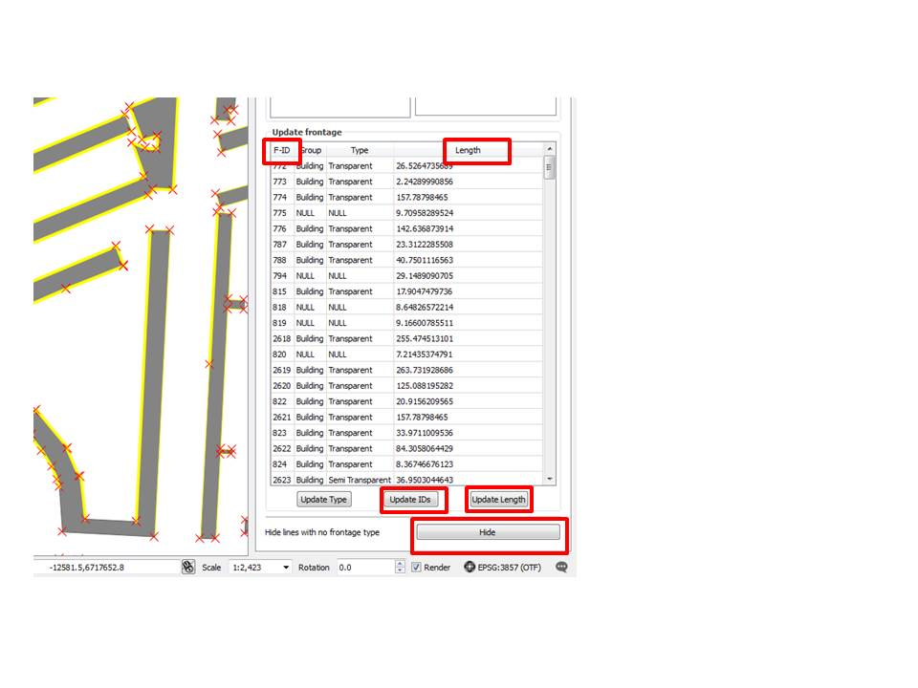

**Stage 2 – Entrances data input**

1. **Create entrance layer**
   1. Shapefile:
      1. Click the **‘Create New’** button
      2. Click the **‘…’** button and select location to save the Shapefile.
      3. Click **OK**
2. **Draw entrances**
   1. Choose one of the following options:
      1. Controlled
      2. Uncontrolled
   2. If you choose **‘Controlled’**, you can choose the following sub categories-
      1. Default
      2. Fire Exit
      3. Service Entrance
      4. Unused
   3. If you choose **‘Uncontrolled’**, you can further choose from the following sub categories -
      1. Default
   4. Select the ‘Add Feature’ from the Digitizing QGIS toolbar.
   5. Draw points at appropriate locations along the respective building.

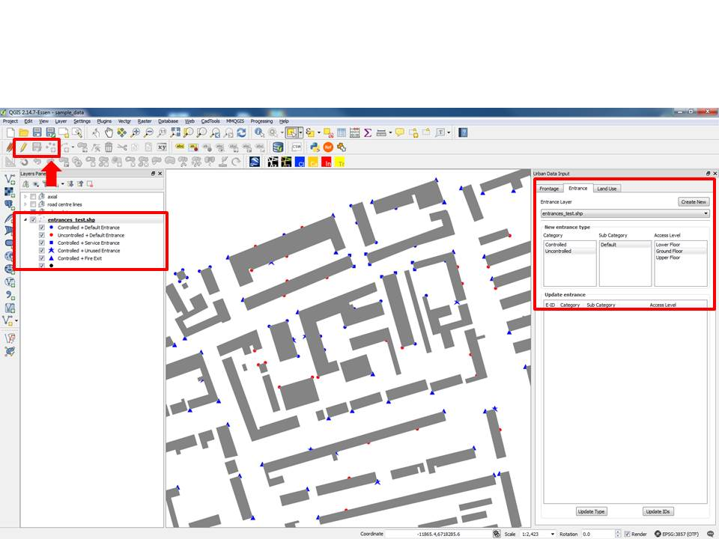

1. **Update entrances**
   1. Select the **Entrance (point)** to update
   2. Observe the attribute values in the data table
   3. Choose one of the following options:
      1. Controlled
      2. Uncontrolled
   4. If you choose **‘Controlled’** you can set one of the sub categories (see above)
   5. If you choose **‘Uncontrolled’** you can further set from the sub category (see above)
   6. Click **‘Update Type’** at the bottom left on the Urban Data Input tool panel

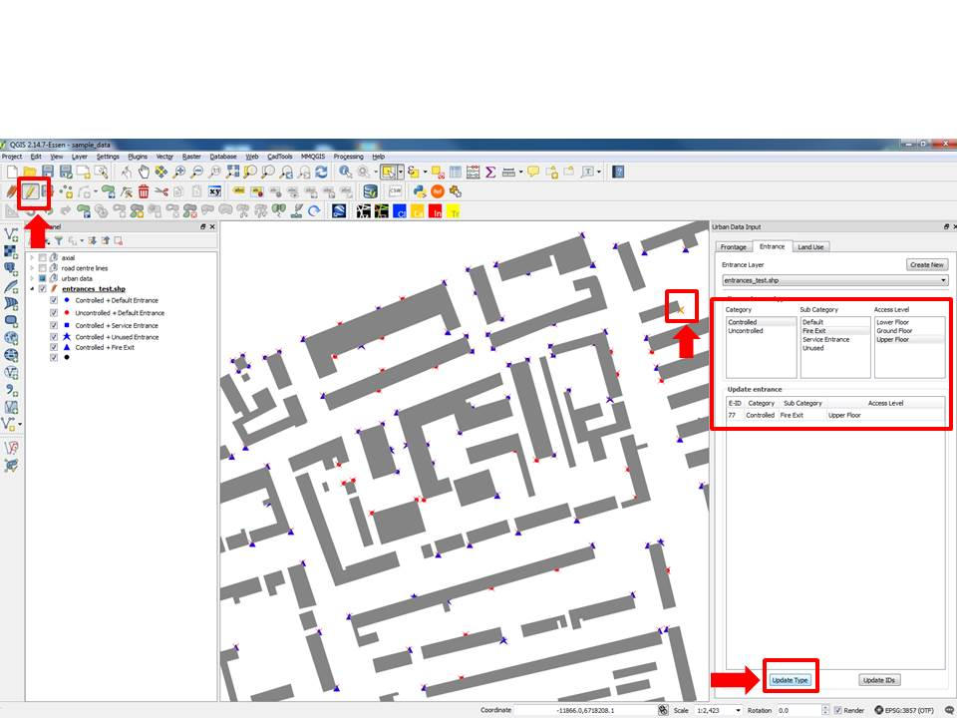

1. **View attributes of selected features of the entrances layer**
   1. Use the **‘Select features’** QGIS tool to select the required entrances.
   2. The attributes related to the selected entrances will now be displayed in the Urban Data Input

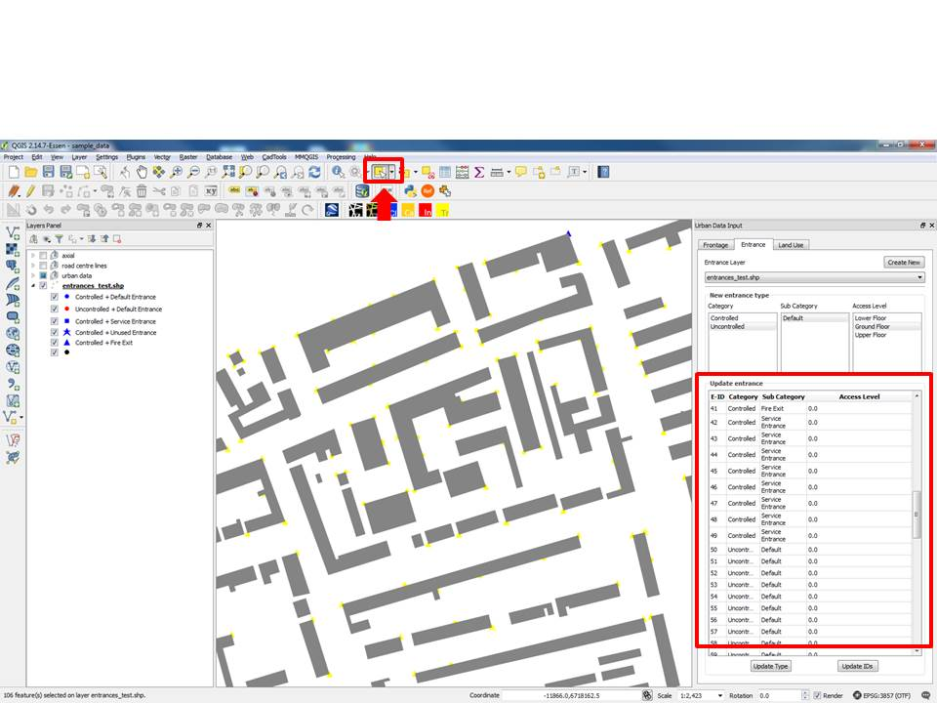

1. **Update Frontages ID**
   1. If you have an Entrances layer loaded on the map canvas press **‘Update IDs’** to update the **‘E-ID’** attribute of the Entrances layer

**Stage 3 – Land use data input**

1. **Create frontage layer**
   1. Select the **‘Land Use’** tab
   2. Click the **‘Create New’** button
   3. Shapefile from existing building layer:
      1. Click the **‘…’** button and select location to save the Shapefile.
      2. Select the **‘Use building layer’** check box.
      3. Select the **‘buildings’ layers** from the drop-down menu.
      4. Select the appropriate ID column from the drop-down menu.
      5. Click **OK**

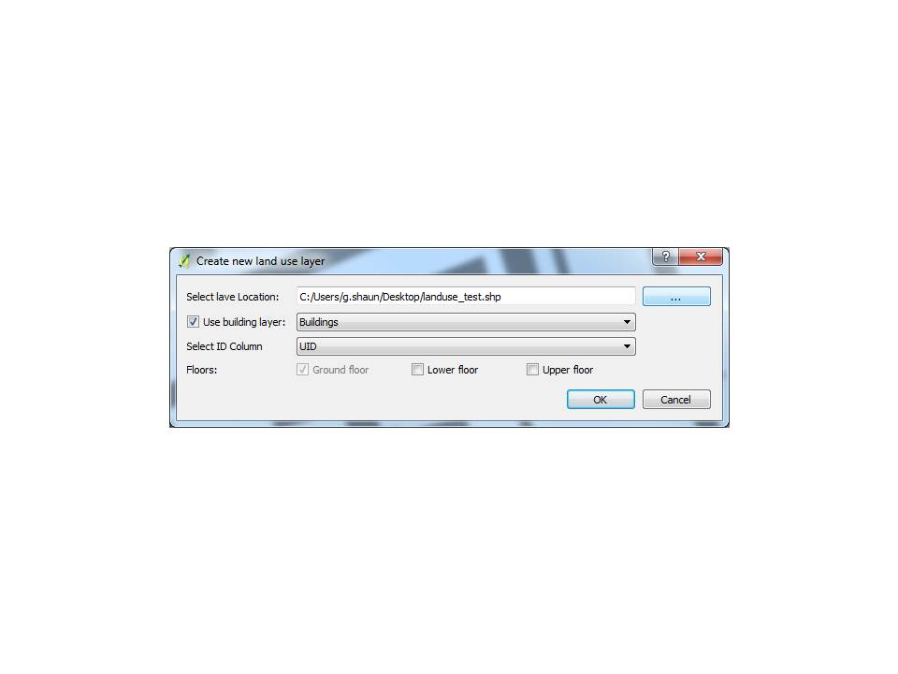

1. **Draw Land Use blocks**
   1. Choose one of the **21** available land use **categories**.
   2. Choose one of the **Sub Category** options if available. Some land use categories also have Sub Categories, e.g. Catering has 3 Sub Categories:
      1. Restaurants and cafes
      2. Drinking Establishments
      3. Hot Food Takeaways
   3. Add an integer for **‘Total number of floors:’** if required. Leave **0** if no data available.
   4. Add **‘Description’** if required. Leave **blank** if no description needed.
   5. Select the **‘Add Feature’** from the Digitizing QGIS toolbar.
   6. Draw polygons to represent the buildings as required.

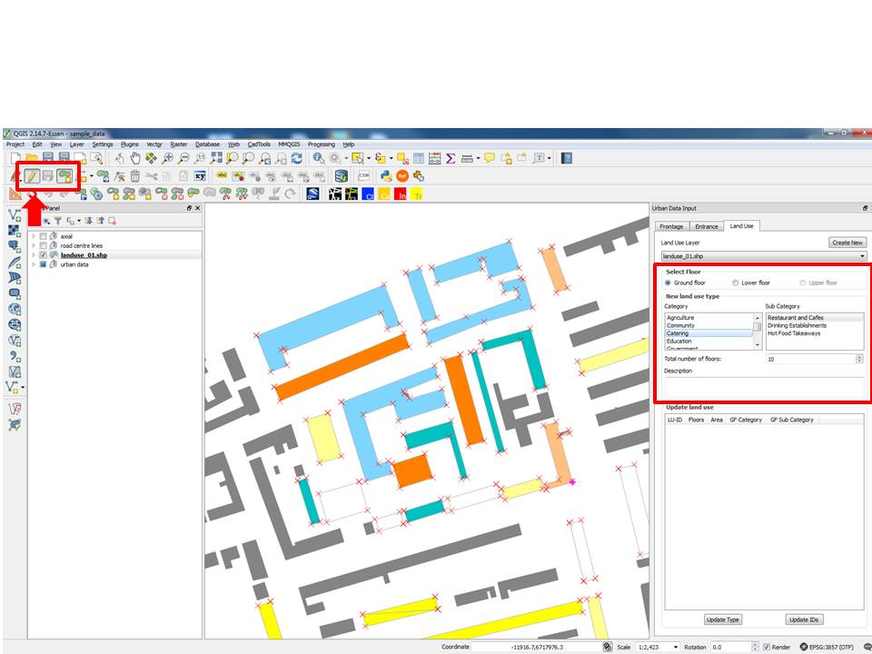

1. **Update Land Use blocks**
   1. Select the **Land Use blocks (polygon)** to update
   2. Choose one of the **21** available land use **categories.**
   3. Choose one of the **Sub Category** options if available.
   4. Add an integer for **‘Total number of floors:’** if required. Leave **0** if no data available.
   5. Add **‘Description’** if required. Leave **blank** if no description needed.
   6. Click **‘Update Type’** at the bottom left on the tool

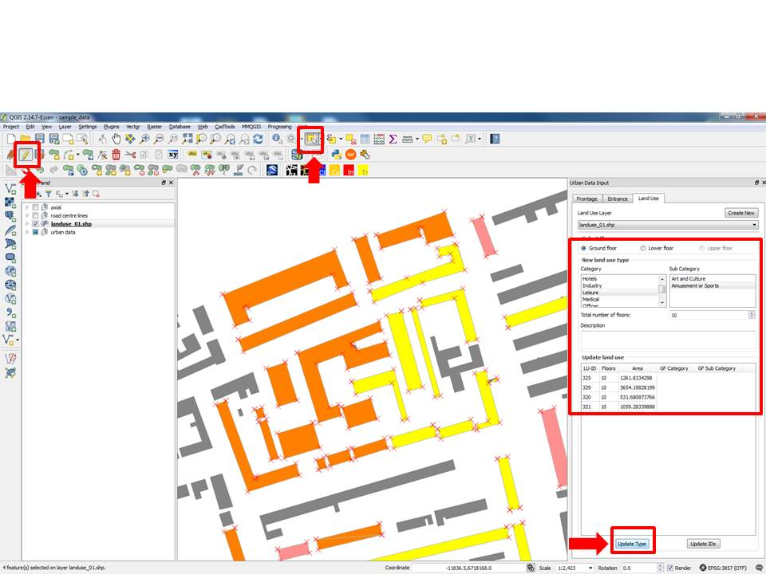

1. **View attributes of selected features of the Land Use layer**
   1. Use the **‘Select features’** QGIS tool to select the required land use blocks.
   2. The attributes related to the selected land use blocks will now be displayed in the Urban Data Input tool.

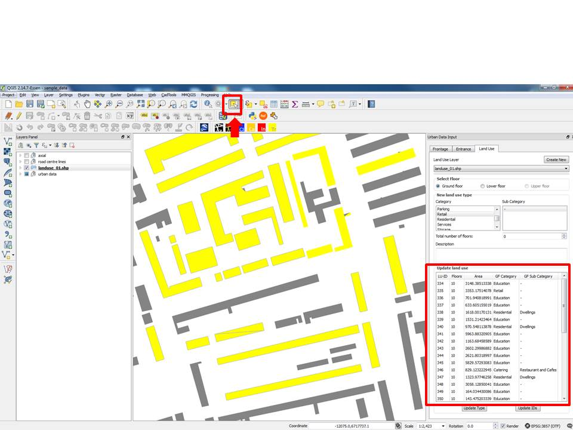

1. **Update Land Use ID**
   1. If you have a Land Use layer loaded on the map canvas press **‘Update IDs’** to update the **‘LU-ID’** attribute of the Land use layer